**Paper review: MapReduce: Simplified Data Processing on Large Clusters**

[**https://dl.acm.org/doi/10.1145/1327452.1327492**](https://dl.acm.org/doi/10.1145/1327452.1327492)

**Parallel & Distributed Database I: Reading List**

**Problem statement**

This paper provides an overview of the motivation for developing MapReduce, which was to simplify the development of large-scale data processing applications that could be distributed across hundreds or thousands of machines. We observed that many of the computations they were performing were conceptually straightforward, but the issues of parallelization, fault tolerance, data distribution, and load balancing made them more complex than necessary.

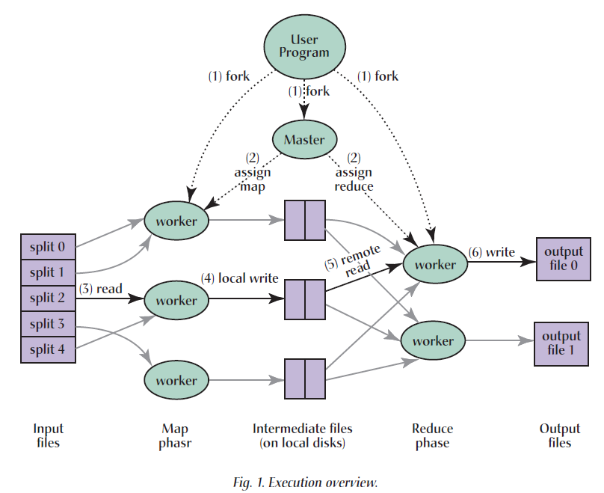To address this complexity, they designed a new abstraction that allowed them to express the simple computations they were trying to perform while hiding the details of parallelization and fault tolerance in a library. The abstraction was inspired by the map and reduce primitives present in Lisp and other functional languages. Most of their computations involved applying a map operation to each input record and then applying a reduce operation to combine the intermediate results.

**Motivation**

1. Chu, C.-T., Kim, S. K., Lin, Y. A., Yu, Y., Bradski, G., Ng, A., and Olukotun, K. 2006. Map-Reduce for machine learning on multicore. In *Proceedings of Neural Information Processing Systems Conference (NIPS)*. Vancouver, Canada.

2. Dean, J. and Ghemawat, S. 2004. MapReduce: Simplified data processing on large clusters. In *Proceedings of Operating Systems Design and Implementation (OSDI)*. San Francisco, CA. 137-150.

These two referenced articles show us that by using the map and reduce functions, programmers can express a wide range of data processing tasks in a concise and expressive manner, while the underlying MapReduce framework takes care of the details of parallelization, fault tolerance, and data management, which can help me support this paper's view: MapReduce plays an important role in developing scalable, fault-tolerant applications that can process massive amounts of data on clusters of commodity hardware.

**Key ideas, techniques, and contributions**

*Key ideas*

1. MapReduce is a programming model for processing large amounts of data in a parallel and distributed manner.
2. The MapReduce model consists of two functions: a map function that processes key-value pairs and generates intermediate key-value pairs, and a reduce function that merges intermediate values associated with the same intermediate key.
3. The MapReduce model provides fault tolerance, locality optimization, load balancing, and other features that hide the details of parallelization from the programmer.

*Techniques*

1. MapReduce uses a master/worker architecture, where the master assigns tasks to workers and monitors their progress.
2. MapReduce uses a distributed file system, Google File System (GFS), to store input and output data.
3. MapReduce uses a shuffle phase to transfer intermediate data from map workers to reduce workers.

*Contributions*

1. The MapReduce model provides a simple and powerful way to parallelize and distribute computations on large clusters of machines.
2. The MapReduce implementation at Google scales to thousands of machines and is fault-tolerant and efficient.
3. MapReduce has been used successfully for a wide variety of tasks at Google, demonstrating its flexibility and usefulness.

**Experimental evaluation**

**Criteria for the line of research**

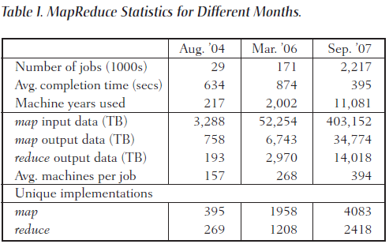This paper provides a detailed experimental evaluation of MapReduce, focusing on scalability, fault tolerance, and performance. They demonstrate that MapReduce can effectively scale to thousands of machines, and show that the locality optimization reduces network traffic and improves performance. It also evaluates the fault tolerance of the system and demonstrate that it can handle machine failures and data loss.

In terms of expressive power, MapReduce provides a restricted programming model that is easy to use for programmers without experience with parallel and distributed systems. While this restricted model may limit the types of computations that can be performed, the authors demonstrate that a wide variety of problems are easily expressible as MapReduce computations, including data generation, sorting, data mining, and machine learning.

In terms of complexity, MapReduce simplifies the programming model by hiding the details of parallelization, fault tolerance, locality optimization, and load balancing. This makes it easy for programmers to parallelize and distribute computations and to make such computations fault tolerant.

**Evaluation based on my own criteria**

**Strong points**

1. Expressive power: The MapReduce programming model is highly expressive and can handle a wide range of computations, including data mining, machine learning, and web indexing. The model's simplicity and ease of use make it accessible to programmers without expertise in parallel and distributed systems.
2. Scalability: The MapReduce implementation has been demonstrated to scale to thousands of machines, making it suitable for large-scale computations. The system makes efficient use of machine resources by optimizing data locality and minimizing network bandwidth usage.
3. Fault tolerance: The MapReduce implementation provides fault tolerance through redundant execution, where each task is executed on multiple machines. The system automatically handles machine failures and data loss, making it more robust and reliable.

**Weak points**

1. Complexity: Although the MapReduce programming model is simple to use, the underlying implementation is complex and requires a significant amount of engineering effort. Developing custom MapReduce functions can also be challenging and require expertise in distributed systems.
2. Accuracy: The MapReduce model is designed for parallelizable computations, which may not be suitable for some tasks that require high precision and accuracy, such as numerical simulations or scientific computing.
3. Limited interactivity: The MapReduce model is designed for batch processing of data, which may not be suitable for applications that require low-latency or real-time processing, such as online transaction processing or interactive data analysis.

**Technical extensions**

Integration with deep learning frameworks: Deep learning has become a popular tool for various machine learning tasks, such as image recognition, speech recognition, and natural language processing. Integrating the MapReduce model with deep learning frameworks, such as TensorFlow or PyTorch, can enable distributed training of large-scale deep neural networks.

Integration with streaming data: Many applications, such as social media analysis and sensor data processing, deal with continuous streams of data. Extending the MapReduce model to handle streaming data can enable real-time processing and analysis of large-scale data streams.

Privacy-preserving data analysis: With the increasing concerns over data privacy and security, it is important to develop techniques for performing data analysis while preserving the privacy of sensitive data. Extending the MapReduce model with privacy-preserving data analysis techniques, such as differential privacy or secure multi-party computation, can enable secure and privacy-preserving data analysis.